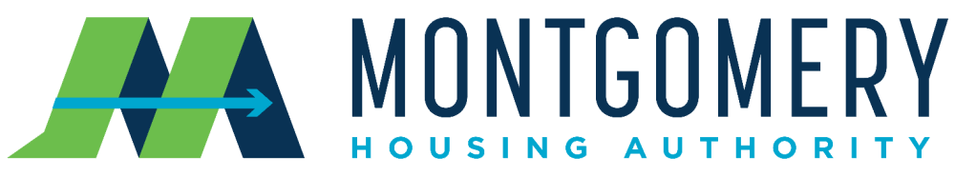

HCV 2024 Payment Standards (Effective 1/1/2024)
Glynis Tanner
Acting President / CEO

John F. Knight, Jr.
Chairman

Montgomery Housing Authority Housing Choice Voucher Program proposed Payment Standards are 105% of the FY 2024 Final Fair Market Rents (FMR) are below:

BEDROOM SIZE | HUD FY 2024 FMR | 2023 PAYMENT STANDARDS (110%) | 2024 PAYMENT STANDARDS (105%)
0 EFFICIENCY | $836 | $787 | $878
1 | $913 | $898 | $959
2 | $1092 | $1074 | $1147
3 | $1383 | $1365 | $1452
4 | $1753 | $1754 | $1841
5 | $2016 | $2190 | $2227
6 | $2279 | $2136 | $2393

The Payment Standards are not guaranteed rental amounts.

The Payment Standards are the maximum subsidy standards for rent and utilities combined given to Housing Choice Voucher families based on bedroom size eligibility.
All rents are subject to a Rent Reasonableness Test and program rules.

P 334.206.7200 | F 334.206.7222 | E info@mhatoday.org 525 South Lawrence St • Montgomery, AL 36104 | MHATODAY.ORG

